**Early Prediction For Chronic Kidney**

**Disease Detection:**

**A Progressive Approach To Health Management**

**TEAM ID: NM_ID: NM2023TMID25270**

**MAGESH.S (4624B1E58A7F8098441232590AEF6A5)**

**MADHAVAN.S (431306209623A095A0AC4FCDED40DDBE3)**

**JAGADEESWARAN.K (4650B61E87656F3171A4D00FF26EDD61)**

**JORAJASURYA.L (3CFD2600069F13C286BF44C685D7B63D2)**

**SUBMITTED FOR THE PROJECT UNDER THE NAAN MUDHALVAN – SMARTINTERNZ PROGRAM.**

|  |  |  |
| --- | --- | --- |
| **1.** | **INTRODUCTION** |  |
|  | **1.1 Overview** |  |
|  | **1.2 Purpose** |  |
| **2.** | **Problem Definition & Design Thinking** |  |
|  | **2.1 Empathy Map** |  |
|  | **2.2 Ideation & Brainstorming Map** |  |
| **3.** | **RESULT** |  |
| **4.** | **ADVANTAGES & DISADVANTAGES** |  |
| **5.** | **APPLICATIONS** |  |
| **6.** | **CONCLUSION** |  |
| **7.** | **FUTURE SCOPE** |  |
| **8.** | **APPENDIX** |  |
|  | 1. **Source Code** |  |

**1.INTRODUCTION**

**1.1 Overview**

Chronic Kidney Disease (CKD) is a major medical problem and can be cured if treated in the early stages. Usually, people are not aware that medical tests we take for different purposes could contain valuable information concerning kidney diseases. Consequently, attributes of various medical tests are investigated to distinguish which attributes may contain helpful information about the disease. The information says that it helps us to measure the severity of the problem, the predicted survival of the patient after the illness, the pattern of the disease and work for curing the disease. In todays world as we know most of the people are facing so many disease and as this can be cured if we treat people in early stages this project can use a pretrained model to predict the Chronic Kidney Disease which can help in treatments of peoples who are suffer from this disease.

**1.2 Purpose**

The goals of early detection are to**prevent the progression of chronic kidney disease and its associated complications**, with subsequent improvements in patient outcomes and reductions in the impact of chronic kidney disease on healthcare resources.

**2.Problem Definition & Design Thinking**

**2.1 Empathy Map**

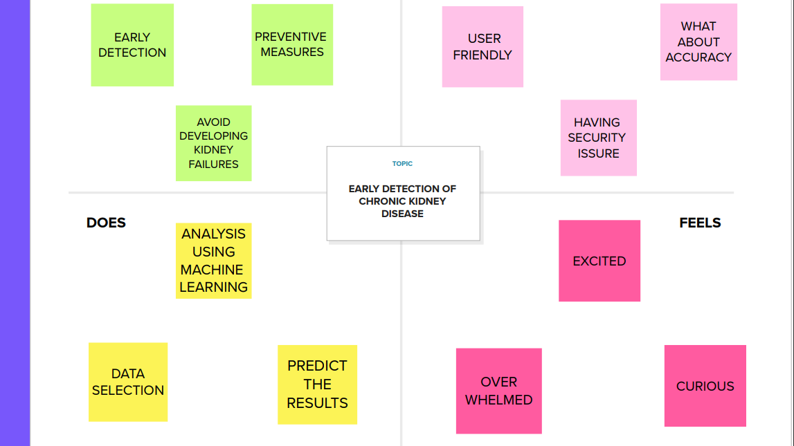

**2.2 Ideation & Brainstorming Map**

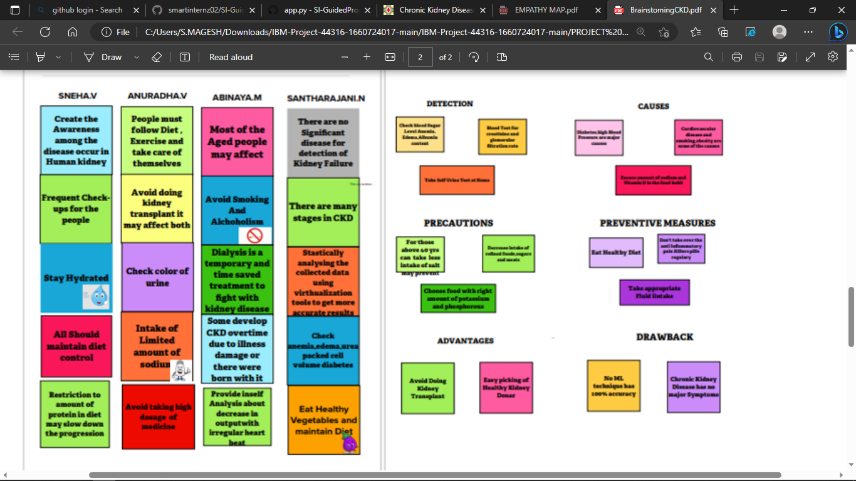

**3. RESULT**

**Input:**

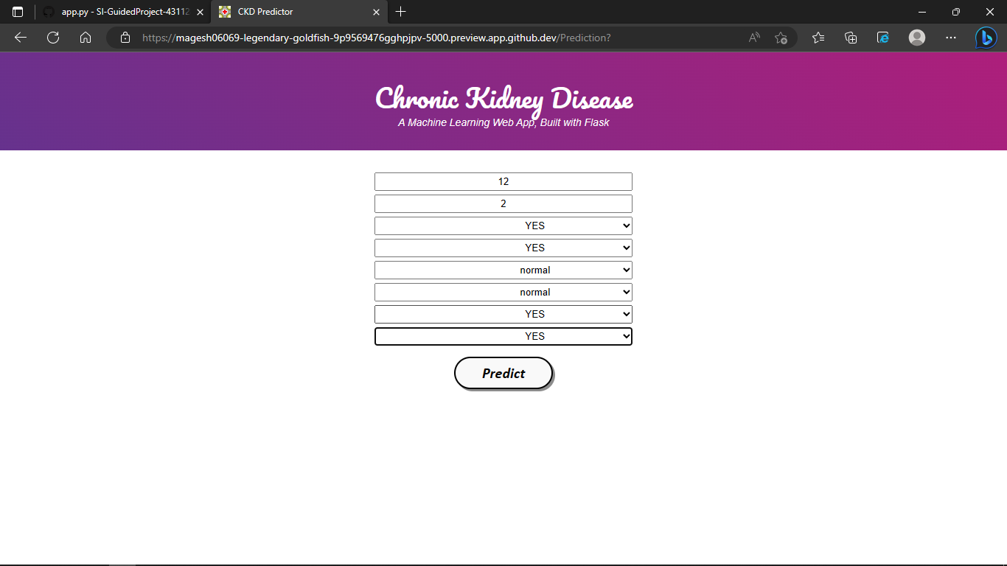

**Output:**

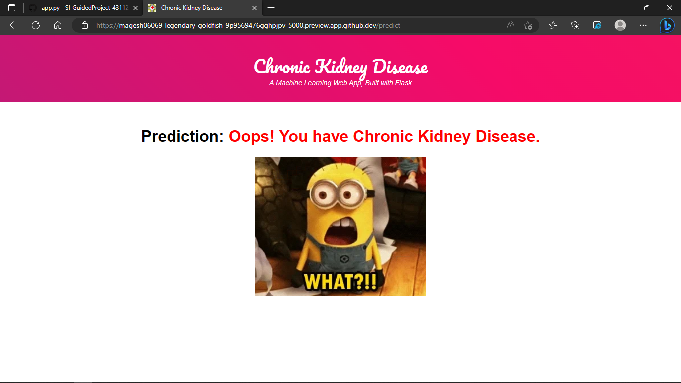

**4. ADVANTAGES & DISADVANTAGES**

* **Advantages**
* The early detection of CKD allows patients to receive timely treatment, s slowing the disease's progression.
* Due to its rapid recognition performance and accuracy, machine learning models can effectively assist physicians in achieving this goal.
* **Disadvantages**
* The accuracy of the model depends on the values supplied by the user, if the values are inaccurate the result will also be inaccurate.

**5.APPLICATIONS**

1. Healthcare & Hospitals

2. Helping and training for medical students

**6.CONCLUSION**

This system presented the best prediction algorithm to predict CKD at an early stage. The dataset shows input parameters collected from the CKD patients and the models are trained and validated for the given input parameters. K-Nearest-Neighbors Classifier, Decision Tree Classifier, GaussianNB, Logical Regression and Artificial Neural Network learning models are constructed to carry out the diagnosis of CKD. The performance of the models is evaluated based on a variety of comparison metrics are being used, namely Accuracy, Specificity, Sensitivity and Log Loss. The results of the research showed that Logical Regression model better predicts CKD in comparison to the other models taking all the metrics under consideration. This system would help detect the chances of a person having CKD further on in his life which would be really helpful and cost-effective people. This model could be integrated with normal blood report generation, which could automatically flag out if there is a person at risk. Patients would not have to go to a doctor unless they are flagged by the algorithms. This would make it cheaper and easier for the modern busy person.

**7.FUTURE SCOPE**

* This would help detect the chances of a person having CKD further on in his life which would be really helpful and cost-effective people.
* This model could be integrated with normal blood report generation, which could automatically flag out if there is a person at risk.
* Patients would not have to go to a doctor unless they are flagged by the algorithms. This would make it cheaper and easier for the modern busy person.

**8. APPENDIX**

**A. Source Code**

App.py # importing the necessary dependencies

import numpy as np

import pandas as pd

from flask import Flask, request, render_template

import pickle

app = Flask(__name__) # initializing a flask app

model = pickle.load(open('lgr.pkl', 'rb')) #loading the model

@app.route('/')# route to display the home page

def home():

return render_template('home.html') #rendering the home page @app.route('/Prediction',methods=['POST','GET']) def prediction():

return render_template('indexnew.html')

@app.route('/Home',methods=['POST','GET'])

def my_home():

return render_template('home.html')

@app.route('/predict',methods=['POST'])# route to show the predictions in a web UI

def predict():

#reading the inputs given by the user

input_features = [float(x) for x in request.form.values()]

features_value = [np.array(input_features)] features_name = ['blood_urea', 'blood glucose random', 'anemia', 'coronary_artery_disease', 'pus_cell', 'red_blood_cells', 'diabetesmellitus', 'pedal_edema']

df = pd.DataFrame(features_value, columns=features_name)

# predictions using the loaded model file

output = model.predict(df)

# showing the prediction results in a UI# showing the prediction results in a UI return render_template('result.html', prediction_text=output)

if __name__ == '__main__':

# running the app

app.run(debug=False)

**HTML :**

**Home.html**

**<!DOCTYPE html>**

**<html>**

**<head>**

**<title>Chronic Kidney Disease Home Page</title>**

**<style>**

**body {**

**background-image: url("1.jpeg");**

**background-repeat: no-repeat;**

**background-size: cover;**

**}**

**#button {**

**position: fixed;**

**top: 10px;**

**right: 20px;**

**color: white;**

**border: none;**

**padding: 6px 12px;**

**font-size: 12px;**

**cursor: pointer;**

**border-radius: 10px;**

**}**

**#button1{**

**position: fixed;**

**top:10px;**

**right: 120px;**

**color: white;**

**border: none;**

**padding: 6px 12px;**

**font-size: 12px;**

**cursor: pointer;**

**border-radius: 10px;**

**}**

**button:hover {**

**background-color: #d32f2f;**

**}**

**.title {**

**position: absolute;**

**top: 50%;**

**left: 50%;**

**transform: translate(-50%, -50%);**

**}**

**.title h1 {**

**text-shadow: 4px 4px #FF0000;**

**font-size: 36px;**

**font-weight: bold;**

**text-align: center;**

**}**

**</style>**

**</head>**

**<body>**

**<a id="button" style="color: red" href="home.html">HOME</a>**

**<a id="button1" style="color: red" href="index1.html">prediction</a>**

**<div class="title">**

**<h1 style="color:white">CHRONIC KIDNEY DISEASE PREDICTION</h1>**

**</div>**

**</body>**

**</html>**

**Index.html**

**<html lang="en" dir="ltr">**

**<head>**

**<meta charset="utf-8">**

**<title>CKD Predictor</title>**

**<link rel="shortcut icon" href="{{ url_for('static', filename='diabetes-favicon.ico') }}">**

**<link rel="stylesheet" type="text/css" href="{{ url_for('static', filename='styles.css') }}">**

**<script src="https://kit.fontawesome.com/5f3f547070.js" crossorigin="anonymous"></script>**

**<link href="https://fonts.googleapis.com/css2?family=Pacifico&display=swap" rel="stylesheet">**

**</head>**

**<body>**

**<!-- Website Title -->**

**<div class="container">**

**<h2 class='container-heading'><span class="heading_font">Chronic Kidney Disease</span></h2>**

**<div class='description'>**

**<p>A Machine Learning Web App, Built with Flask</p>**

**</div>**

**</div>**

**<!-- Text Area -->**

**<div class="ml-container">**

**<form action="{{ url_for('predict') }}" method="POST">**

**<style>**

**select {**

**text-indent: 29%;**

**text-align: center;**

**width: 350px;**

**height: 25px;**

**margin-bottom: 5px;**

**}**

**</style>**

**<input class="form-input" type="text" name="blood_urea" placeholder="Enter your blood_urea"><br>**

**<input class="form-input" type="text" name='blood glucose random' placeholder="Enter your blood glucose random"><br>**

**<select id="anemia" name="anemia">**

**<option value="">Select anemia or not</option>**

**<option value="1">YES</option>**

**<option value="0">NO</option>**

**</select><br>**

**<select id="coronary_artery_disease" name="coronary_artery_disease">**

**<option value="">Select coronary artery disease or not</option>**

**<option value="1">YES</option>**

**<option value="0">NO</option>**

**</select><br>**

**<select id="pus_cell" name="pus_cell">**

**<option value="">Select pus_cell or not</option>**

**<option value="0">normal</option>**

**<option value="1">abnormal</option>**

**</select><br>**

**<select id="red_blood_cell" name="red_blood_cell">**

**<option value="">Select red_blood_cell level</option>**

**<option value="0">normal</option>**

**<option value="1">abnormal</option>**

**</select><br>**

**<select id="diabetesmellitus" name="diabetesmellitus">**

**<option value="">Select diabetesmellitus or not</option>**

**<option value="1">YES</option>**

**<option value="0">NO</option>**

**</select><br>**

**<select id="pedal_edema" name="pedal_edema">**

**<option value="">Select pedal_edema or not</option>**

**<option value="1">YES</option>**

**<option value="0">NO</option>**

**</select><br>**

**<input type="submit" class="my-cta-button" value="Predict">**

**</form>**

**</div>**

**</body>**

**Result.html**

**<html lang="en" dir="ltr">**

**<head>**

**<meta charset="utf-8">**

**<title>Chronic Kidney Disease</title>**

**<link rel="shortcut icon" href="{{ url_for('static', filename='diabetes-favicon.ico') }}">**

**<link rel="stylesheet" type="text/css" href="{{ url_for('static', filename='styles.css') }}">**

**<script src="https://kit.fontawesome.com/5f3f547070.js" crossorigin="anonymous"></script>**

**<link href="https://fonts.googleapis.com/css2?family=Pacifico&display=swap" rel="stylesheet">**

**</head>**

**<body>**

**<!-- Website Title -->**

**<div class="container">**

**<h2 class='container-heading'><span class="heading_font">Chronic Kidney Disease</span></h2>**

**<div class='description'>**

**<p>A Machine Learning Web App, Built with Flask</p>**

**</div>**

**</div>**

**<!-- Result -->**

**<div class="results">**

**<h1>Prediction: <span class='danger'>Oops! You have Chronic Kidney Disease.</span></h1>**

**<img class="gif" src="result1.jpeg" alt="Diabetes Image">**

**<h1>Prediction: <span class='safe'>Great! You DON'T have Chronic Kidney Disease</span></h1>**

**<img class="gif1" src="result2.jpeg" alt="Not Diabetes Image">**

**</div>**

**</body>**

**</html>**